**Lab Assignment-9**

**Screenshots**

Used Mixin pattern to register:

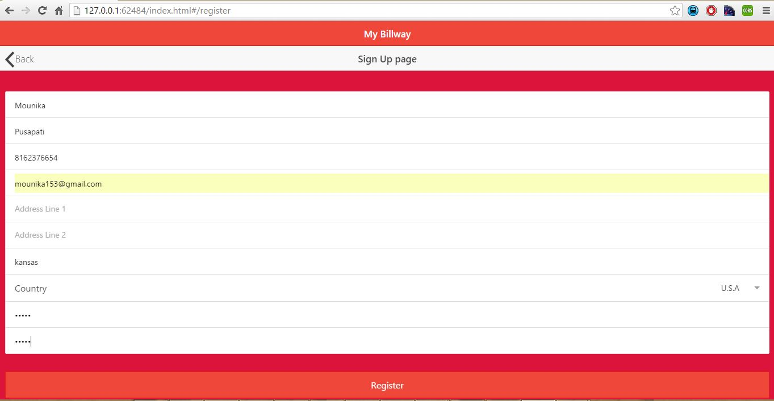

Used mixin pattern while navigating from login to home page:

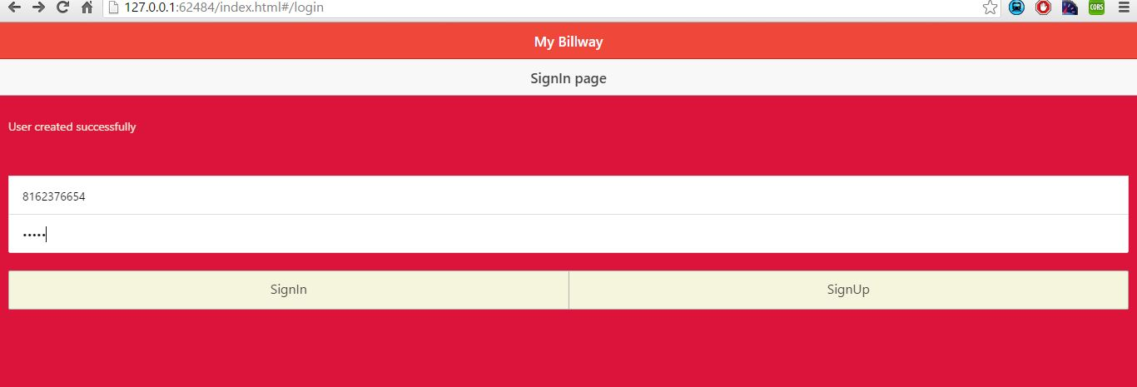

Used mixin pattern for updating user's profile:

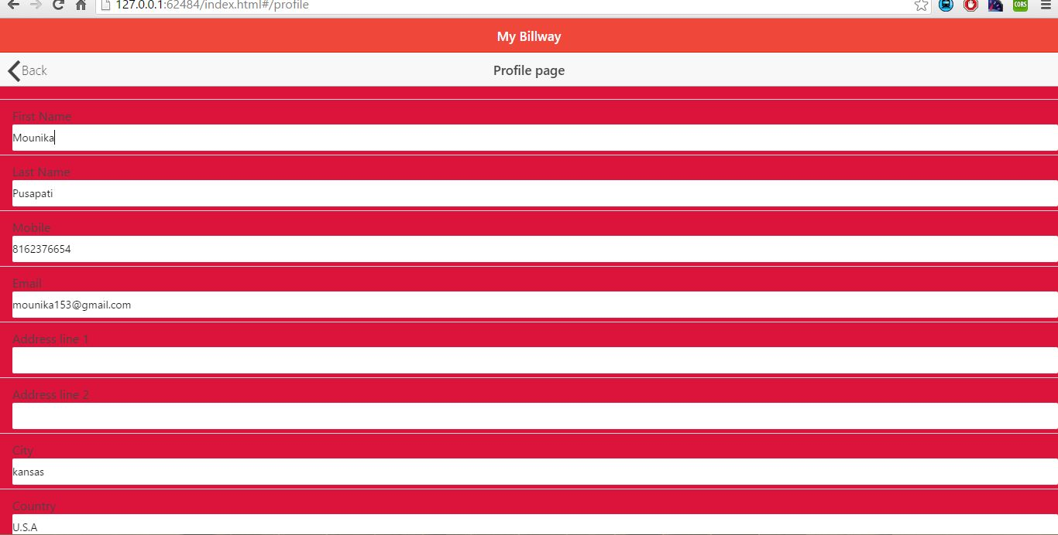

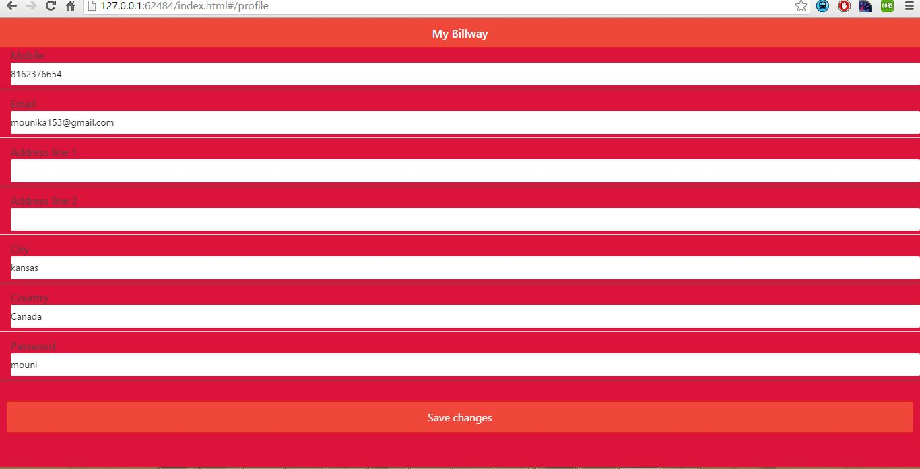

Mixin pattern code:

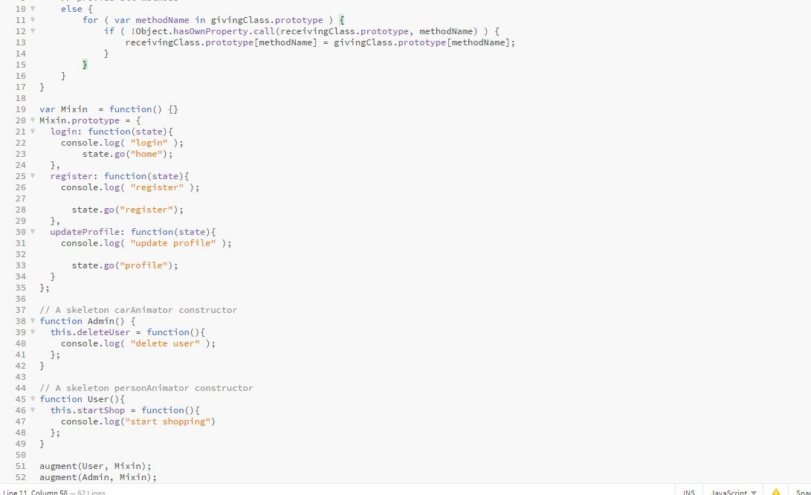

Used Singleton pattern for signing into application by verifying user credentials:



Singleton pattern code:

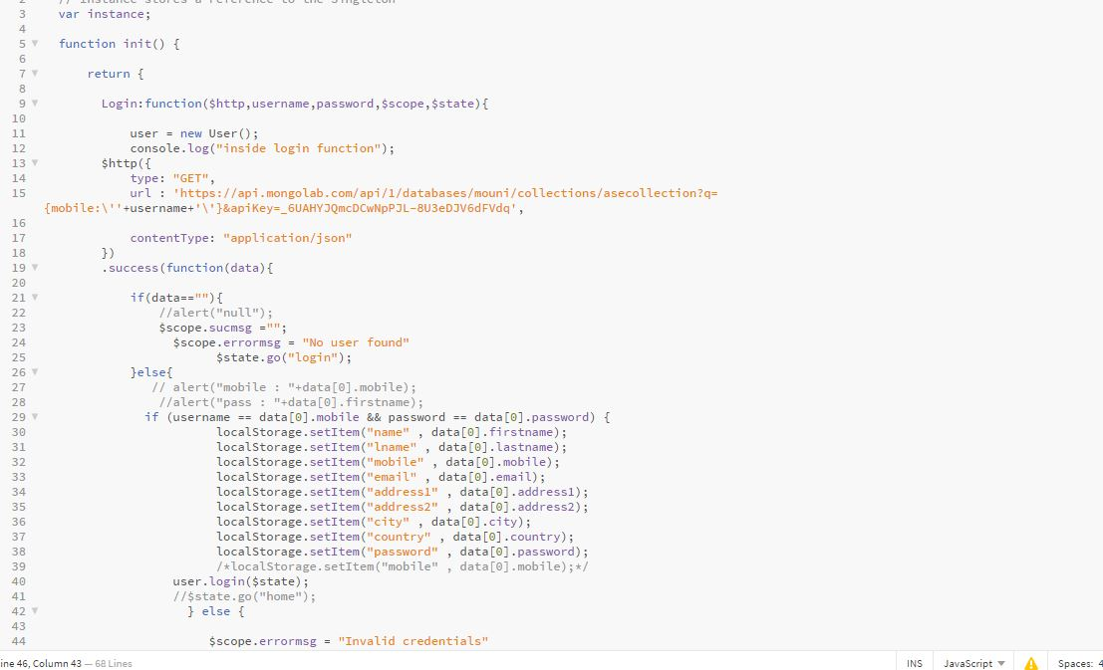

Used factory pattern for displaying user details in home page:

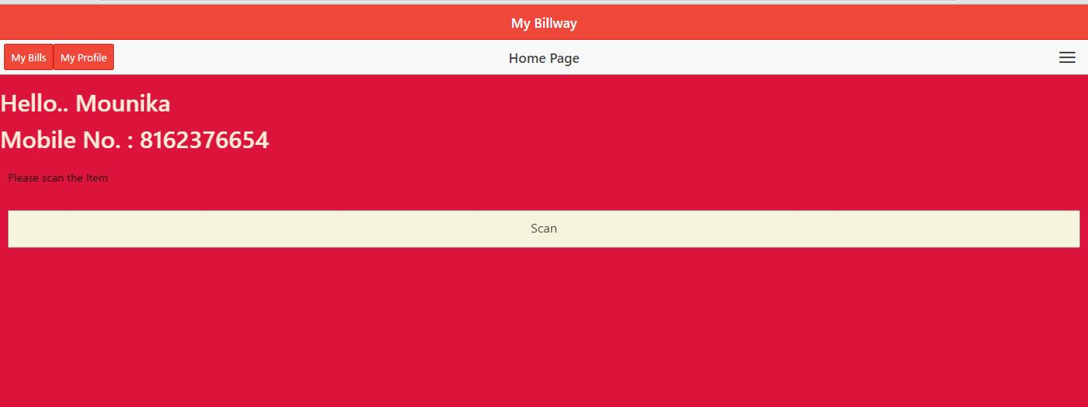

Factory pattern code:

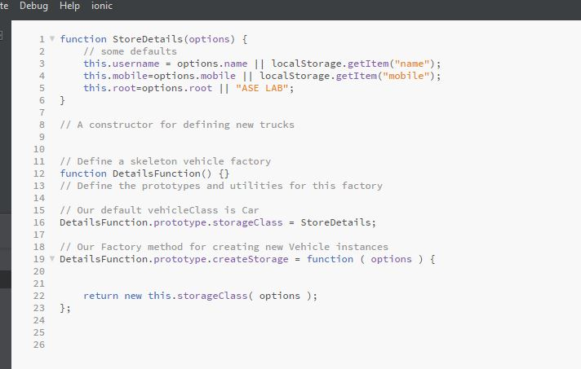

Deployed application in Bluemix:

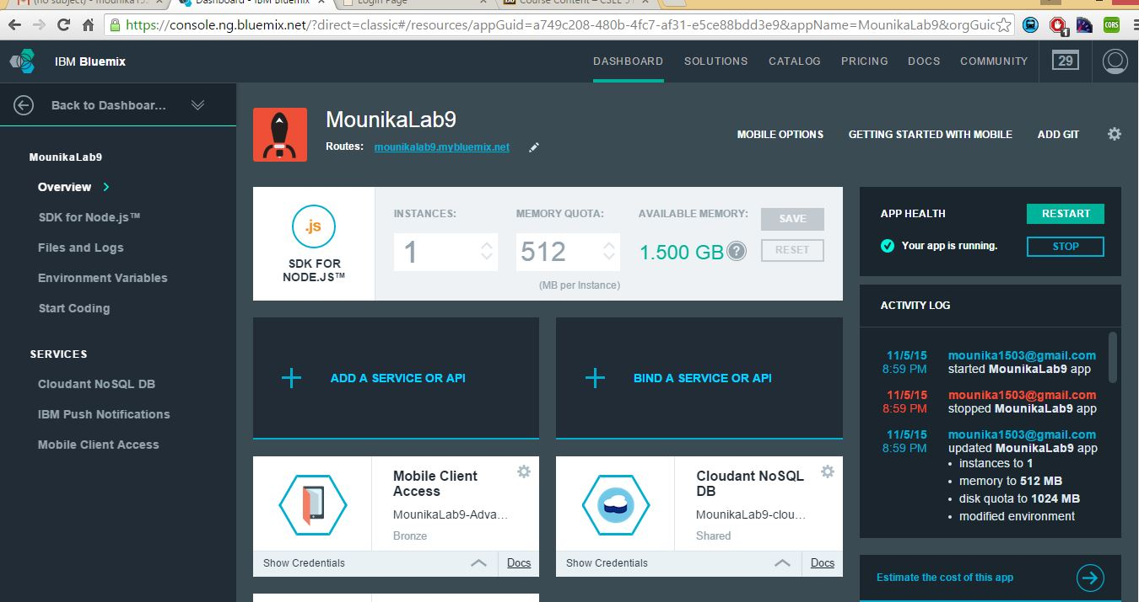

**Application in Bluemix:**

Sign In page:

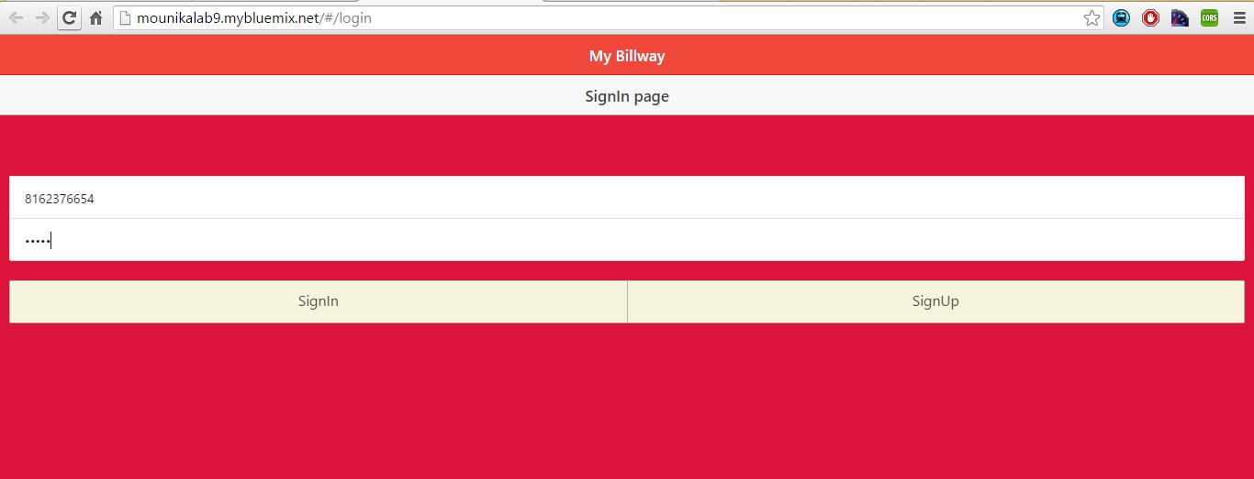

Home page:

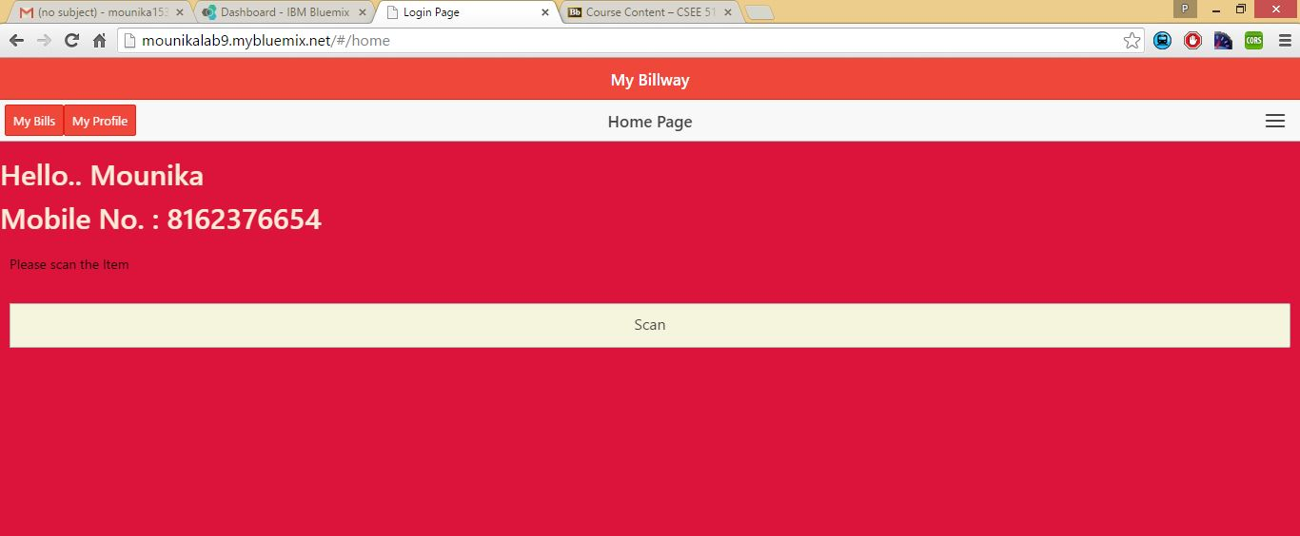

Sign Up page: